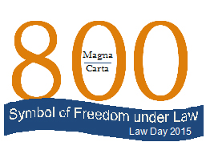

PBA Law Day 2015 - Local Bar Association Registration & Request for Materials Form

Please complete and return this form to the Pennsylvania Bar Association, by fax: 717-221-8739,
email: susan.etter@pabar.org or mail to: 100 South Street, P.O. Box 186, Harrisburg, PA 17108-0186.
Please submit one form per bar association. Thank you.

The ________________________ County Bar Association will join with the Pennsylvania Bar Association in celebrating Law Day 2015.
Contact Information
Contact Name:
Address to send requested materials:
Phone Number: |  | Fax Number:
E-mail Address:

Request for Materials
Requested # | Item Requested
 | Pocket U.S. Constitutions (As needed – FYI, 1 box contains about 250 constitutions)
Constitution Preamble Bookmarks
County bars may receive a maximum of 200.
Gavel Pencils
County bars may receive a maximum of 100 gavel pencils.

Signature of Individual Completing Form | County Bar Association Position

Law Day is funded by the Pennsylvania Bar Foundation and coordinated by the PBA Law-Related Education Committee.

